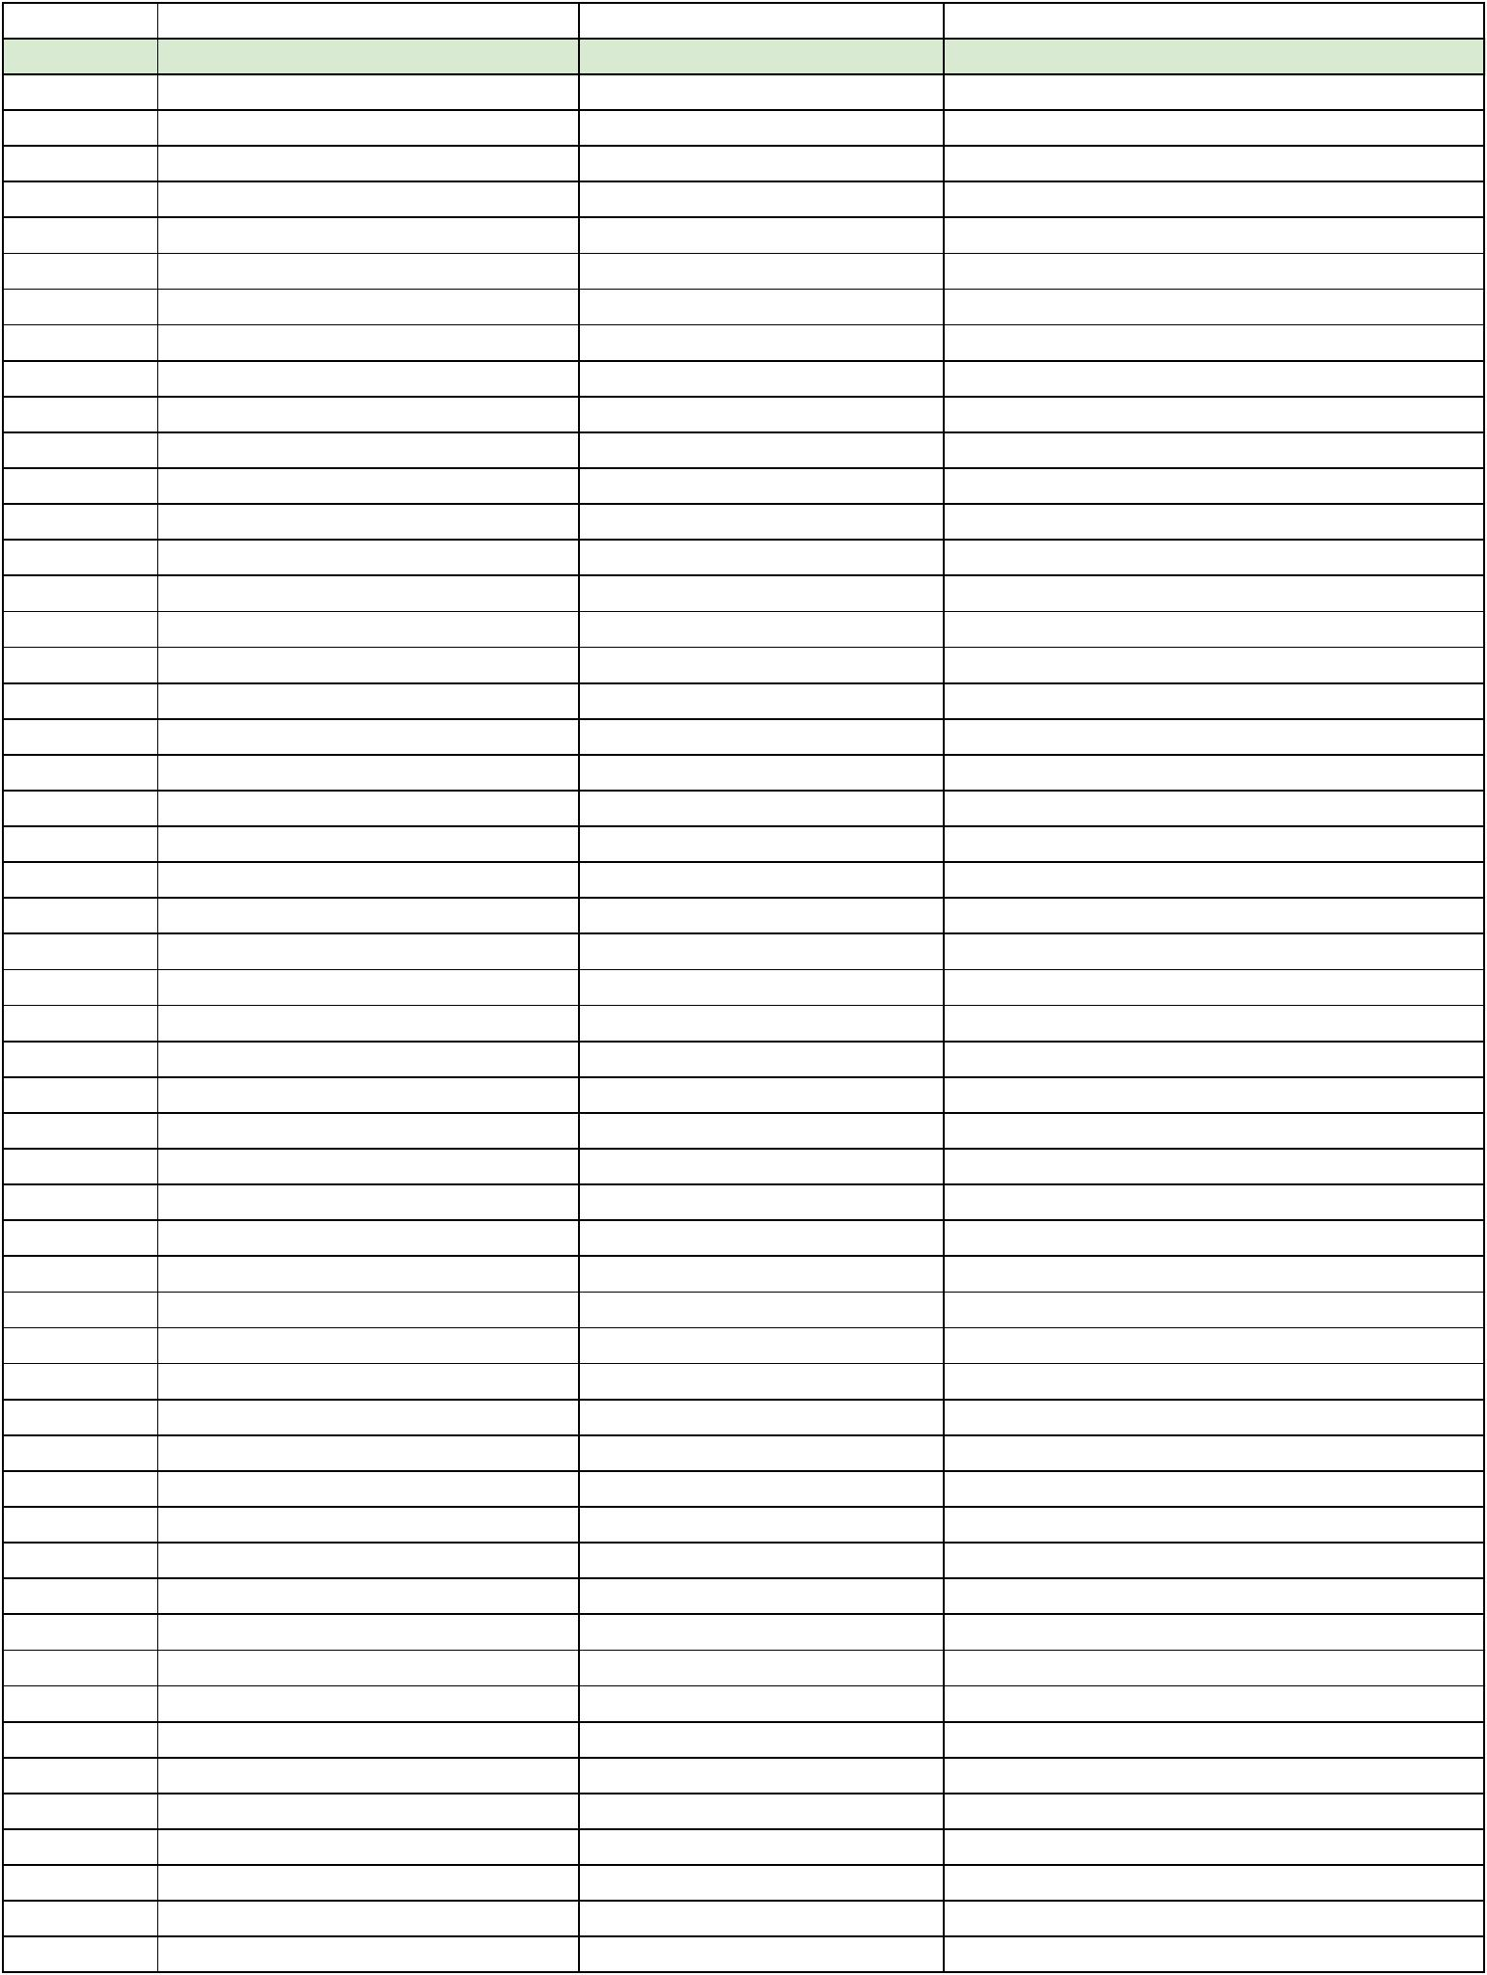**Approx. Time** **When** **Artist** **Song**

|  |  |  |
| --- | --- | --- |
| 5:30 PM Guest Arrival at the Farm | Lounge Music |  |
| 6:00 PM Welcome Prosecco/Cocktail Hour | Lounge Music |  |
| 6:45 PM Grand Entrance Introduction | U2 | Beautiful Day |
| 7:00 PM Dinner Music | Getz Gilberto |  |
|  | Thievery Corporation |  |
| 7:30 PM Speeches | Doug Paul - Father of the Groom |  |
|  | Dad Conlon - Father of the Bride |  |
|  | Mom Conlon - Mother of the Bride |  |
|  | Melissa Durst - Maid of Honor |  |
|  | Stein - Groomsman |  |
|  | *Open Mic - invite others to speak* |  |
|  | Stacy & Hendrik |  |
| 8:15 PM H&S First Dance | Patty Griffin | Heavenly Day |
| 8:20 PM Dance w/ Parents | Frank Sinatra | The Way You Look Tonight |
| 8:30 PM Open Dance Floor | Traditional German Music |  |
| Beginning of the Night | ABBA |  |
|  | Alabama | Song of the South |
|  | Aretha Franklin |  |
|  | Beatles | Twist and Shout |
|  | Diana Ross | Upside Down |
|  | Donna Somers |  |
|  | Eddie Money | Take Me Home Tonight |
|  | Eddy Grant | Electric Avenue |
|  | Ella Fitzgerald |  |
|  | Frank Sinatra | It Had to Be you |
|  | Frank Sinatra | New York New York |
|  | Frank Sinatra | The Way You Look Tonight |
|  | Huey Lewis & the News | I Wanna New Drug |
|  | Herbert Grunemeyer | 99 Luftballons |
|  | John Legend | All of Me |
|  | Kenny Loggins | Footloose |
|  | Lionel Ritchie | All Night Long |
|  | Marvin Gaye | Got to Give it Up |
|  | Michael Jackson | Pretty Young Thing |
|  | Michael Jackson | The Way You Make Me Feel |
|  | Neil Diamond | America |
|  | Phil Collins | Sussudio |
|  | Phil Collins | Don't Lose My Number |
|  | Randy Travis | Forever and Ever, Amen |
|  | Ray Lamantaine | You are the best thing |
|  | Sam cook |  |
|  | Smokey Robinson | Tears of a Clown |
|  | Talking Heads | This Must be the Place |
|  | Temptations | Aint Too Proud to Beg |
|  | When in Rome | The Promise |
|  | Whitney Houston | I Wanna Dance With Somebody |
|  | Wilson Picket | Mustang Sally |
|  | Wolfgang Petry |  |
| Middle of the Night | 80s |  |
|  | Anamotion | You're my Obsession |
|  | Blondie | Hearts of Glass |

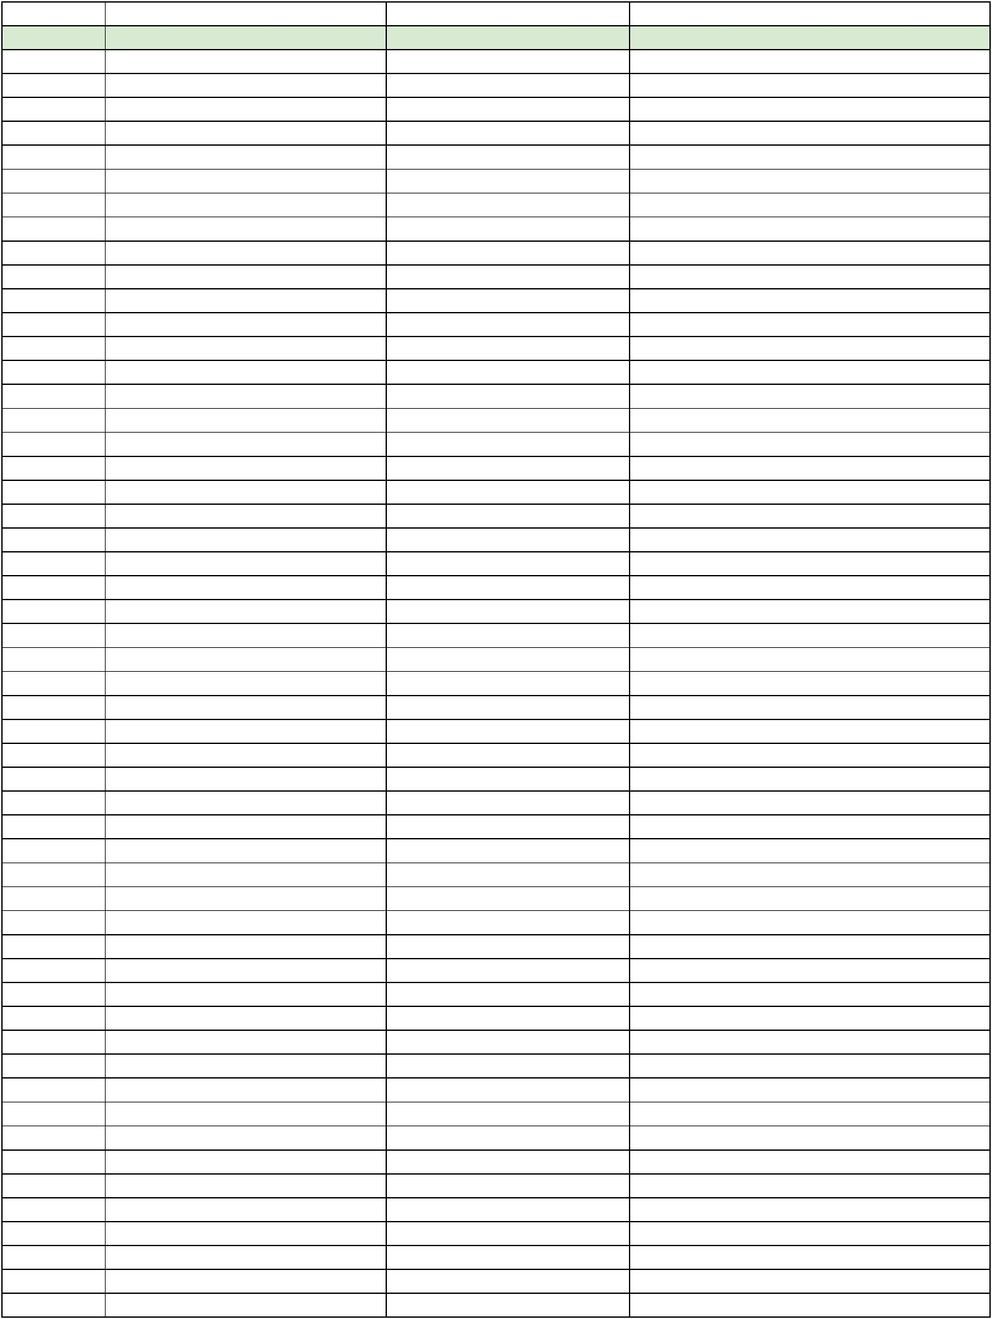**Approx. Time** **When** **Artist** **Song**

|  |  |  |
| --- | --- | --- |
|  | BoB ft. Bruno Mars | Nothing on You |
|  | Cat Edmonton |  |
|  | Coldplay | Adventure of a Lifetime |
|  | Coldplay | Sky Full of Stars |
|  | Dolly Parton | 9 to 5 |
|  | Ellie Goulding | Lights, other songs |
|  | Empire of the Sun | High and Low |
|  | Empire of the Sun | Walking on a Dream |
|  | Empire of the Sun | Alive |
|  | JayZ | Empire State of Mind |
|  | Lionel Ritchie | All Night Long |
|  | Lionel Ritchie | Stuck on You |
|  | Madonna | Borderline |
|  | Madonna | Like a Prayer |
|  | Madonna | Holiday |
|  | Men Without Hats | The Safety Dance |
|  | Price | Kiss |
|  | Prince | 1999 |
|  | Prince | I Wanna Be Your Lover |
|  | Queen | Somebody to Love |
|  | RAC | Hollywood |
|  | Snoop Dogg | Beautiful |
|  | St Lucia | Dancing on Glass |
|  | Tears for Fears | Everybody Wants to Rule the World |
|  | The Cure |  |
|  | Toto | Land Down Under |
|  | U2 | *Anything! We love U2* |
| Later Night Dancing | Avicii | Levels |
|  | Beyonce | Crazy in Love |
|  | Black Eyed Peas | I Gotta Feeling |
|  | Bruno Mars | 24 Karat Gold |
|  | Calvin Harris | Feel So Close |
|  | Calvin Harris & Rihanna | We Found Love |
|  | Chris Brown | Forever |
|  | Cut Copy | Lights and Music |
|  | Daft Punk | Get Lucky |
|  | Daft Punk | One More time |
|  | Disclosure |  |
|  | DNCE | Cake by the Ocean |
|  | Duran Duran | Girls on Film |
|  | Flo Rida | Wild One |
|  | Flo Rida | Good Feeling |
|  | Flo Rida | Low |
|  | Flo Rida | My House |
|  | Flume |  |
|  | George Michael | Faith |
|  | Guns and Roses | Sweet Child O Mine |
|  | Guns and Roses | Paradise City |
|  | Hayden James | There's Something About You |
|  | Icona Pop | I Love It |
|  | Iggy Azelea | Fancy |
|  | Jay Z | I just wanna love you |
|  | Jess Glynne | Rather Be |

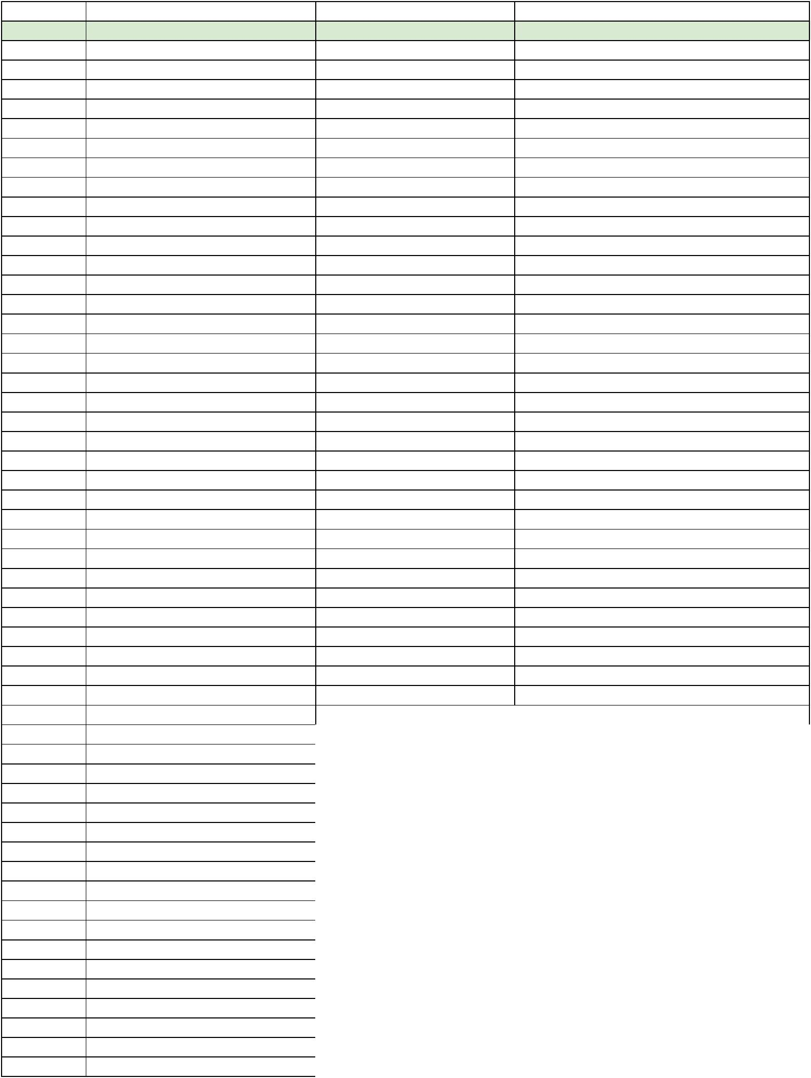**Approx. Time** **When** **Artist** **Song**

|  |  |  |
| --- | --- | --- |
|  | Justice | D.A.N.C.E. |
|  | Justin Timberlake | Rock Your Body |
|  | Justin Timberlake | SexyBack |
|  | Killers | Human |
|  | Kylie Minoge |  |
|  | Mark Ronson | Uptown Funk ft. Bruno Mars |
|  | Mase | Feel so good |
|  | MGMT | Electric Feel |
|  | Notorious BIG | Hyptnotize |
|  | Odesza | All We Need |
|  | Odesza | Sun Models |
|  | Odesza | Say My Name |
|  | Outkast | Ms Jackson |
|  | Pete Tong | Children |
|  | Rihanna ft Calvin Harris | We Found Love |
|  | Sia | Alive |
|  | Sia | Cheap Thrills |
|  | Sneaky Soundsystem |  |
|  | Snoop Dogg & 2Pac | California Love |
|  | Snoop Dogg & Wiz Kalifa | Young, Wild and Free ft. Bruno Mars |
|  | Sugarhill Gang | Rapper's Delight |
|  | Taylor Swift |  |
|  | The Weekend | Starboy |
|  | The Weekend | I Can't Feel My Face When I'm With You |
|  | The Weekend | I Feel it Coming |
|  | Zhu | Hometown Girl |
|  |  |  |
|  | **DO NOT PLAY List** |  |
|  | Montell Jordan | This is How We Do It |
|  | Stevie Wonder | Signed Sealed Deliver |
|  | Kool and the Gang | Jungle Boogie |
|  | Celebration |  |
|  | We are Family |  |
|  |  |  |
|  | **Our Record Collection for More Inspiration** | |
|  | 2 Pac | All Eyes on Me |
|  | 5th Dimension | Portrait |
|  | 5th Dimension | The Age of Aquarius |
|  | 5th Dimension | Up Up and Away |
|  | A Little Bit of Ireland | Compilation |
|  | ABBA | Greatest Hits |
|  | Alabama | Feels So Right |
|  | Alabama | Greatest Hits |
|  | Alexandra Story, Die | Stimme der Sehnsucht |
|  | Alina Baraz & Galimatias | Urban Flora |
|  | Alive Cooper | School's Out |
|  | Ambassador Satch | European Concert Recordings |
|  | Amy Winehouse | Back to Black |
|  | Andy Stewart | Scotch Corner |
|  | Andy Williams | Warm and Willing |
|  | Andy Williams | Dear Heart |
|  | Andy Williams | Moon River |
|  | Arthur Murray | Music for Dancing |

**Approx. Time** **When** **Artist** **Song**

|  |  |  |
| --- | --- | --- |
|  | Artie Shaw | In The Blue Room |
|  | Bambi | Disney Presents |
|  | Barbara Streisand | People |
|  | Barry Manilow | The Very Best of Barry Manilow |
|  | Beach Boys | 15 Big Ones |
|  | Beach Boys | The Best of the Beach Boys |
|  | Beatles | Beatles '65 |
|  | Beethoven | Sonatas for Violin and Piano |
|  | Beethoven, Ludwig von | String Quartet in C Sharp |
|  | Bert Kaempfert | The Best of the Bert Kaempfert |
|  | Beverly Hills Cop | Beverly Hills Cop |
|  | Billie & De De | New Orleans Jazz |
|  | Billie Holiday | Lady in Satin |
|  | Billy Joel | An Innocent Man |
|  | Bing Crosby | The Best of Bing |
|  | Bing Crosby | Greatest Hits |
|  | Blue Oyster Cult | Agents Of Fortune |
|  | Bob Dylan | Bob Dylan's Greatest Hits |
|  | Bon Iver | For Emma, Forever Ago |
|  | Boston | Boston |
|  | Bothy Band | The Best of Bothy Band |
|  | Brandon Flowers | Flamingo |
|  | Brandon Flowers | The Desired Effect |
|  | Bread | The Best of Bread |
|  | Breakfast At Tiffany's | Breakfast At Tiffany's |
|  | Broadway Cocktail Party | The Sound of Magnificence |
|  | Brother Ali | The Undisputed Truth |
|  | Bruce Springsteen | Born in the U.S.A |
|  | C'Est Chic! | French Girl Singers of the 1960s |
|  | Camboy Estevez | Que Pasa Entre Los Dos |
|  | Caribou | Swim |
|  | Carlos Montoya | Plays Latin Favorites |
|  | Carlos Montoya | Malaguena |
|  | Carmen | Bizet |
|  | Carpenters | The Singles 1969-1973 |
|  | Carpenters | Carpenters |
|  | Casino Royale | Casino Royale |
|  | Cat Stevens | Greatest Hits |
|  | Charley Pride | From Me To You |
|  | Charley Pride | Country |
|  | Cheap Trick | Dream Police |
|  | Chieftains | The Chieftains 4 |
|  | Clancy Brothers | Greatest Hits |
|  | Clancy Brothers | Flowers In The Valley |
|  | Clancy Brothers & Tommy Makem | Isn't It Grand Boys |
|  | Clannad | Macalla |
|  | Coldplay | A Head Full of Dreams |
|  | Coldplay | Myloxyloto |
|  | Coldplay | Ghost Stories |
|  | Compilation | Barbershop Champions |
|  | Compilation | Best of the Great Pop-Country Favorites |
|  | Compilation | The Best of 66 |
|  | Compilation | The Motown Story - The First 25 Years |

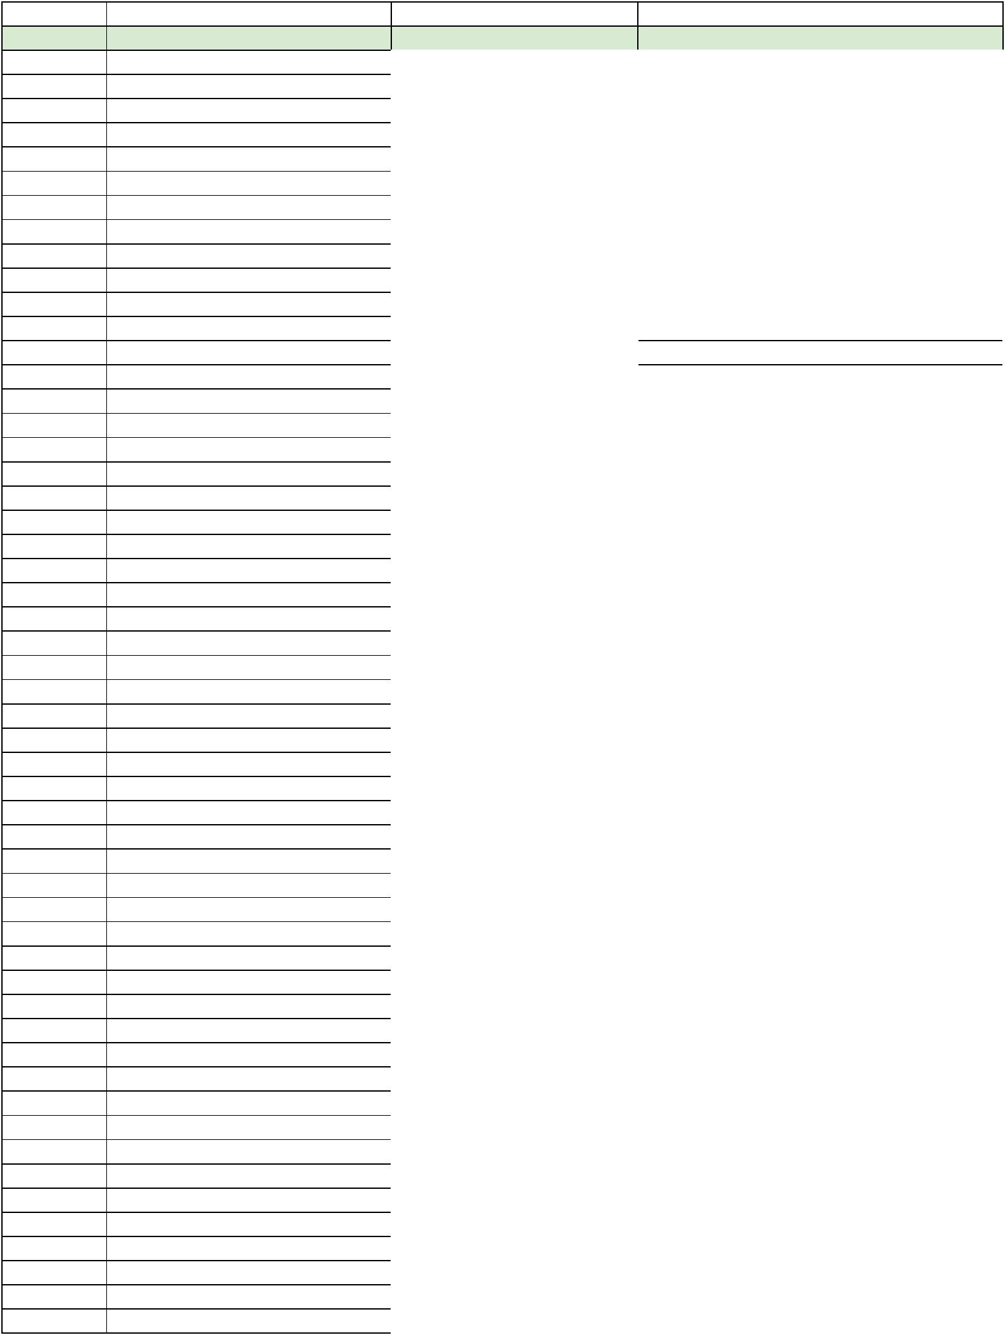**Approx. Time** **When** **Artist** **Song**

|  |  |  |
| --- | --- | --- |
|  | Compilation | Classic Scots Ballads |
|  | Compilation | Disco Dancer |
|  | Compilation | Five Ladies of Song |
|  | Compilation | Great Songs of Christmas |
|  | Compilation | Greatest Hits of the Fantastic 50's |
|  | Compilation | Greatest Country Hits of the 70's |
|  | Compilation | Hooray for Hollywood 1930s-1950s |
|  | Compilation | House Party |
|  | Compilation | Immortal Songs of Germany |
|  | Compilation | Jazz and Hot Dance in Switzerland (1921-1952) |
|  | Compilation | Jazz of the Roaring 20s |
|  | Compilation | Live For Ireland |
|  | Compilation | Mind of a Genius |
|  | Compilation | Ohne Hemd und ohne Höschen |
|  | Compilation | Operas, Symphonies & Ballet |
|  | Compilation | Persuasive Percussion |
|  | Compilation | R&B Jams |
|  | Compilation | Secret Love |
|  | Compilation | Singing Sex Symbols of the Airwaves 1930s |
|  | Compilation | Stars of the Apollo Theatre |
|  | Compilation | The Big Chill |
|  | Compilation | The Golden Age of Entertainment |
|  | Compilation | The Roaring 20's Vol. 3 |
|  | Compilation | Those Wonderful Thirties - Broadway & Night Clubs |
|  | Compilation | Those Wonderful Thirties - Hollywood's Golden Era |
|  | Dance Capades | Jazz Ballet Tap |
|  | Danceland | 12 Show Stopping Arrangements |
|  | Daft Punk | Random Access Memories |
|  | Daniel Santos | El Contragolpe |
|  | Dave Brubeck Quartet | Time Out |
|  | Diana Ross & the Supremes | Love Child |
|  | Die Zauberflöte | Wolfgang Amadeus Mozart |
|  | Dionne Warwick | Valley of the Dolls |
|  | Disclosure | Settle |
|  | Disclosure | Caracal |
|  | Disney's Family Reunion | 12 Favorite Songs From Disney |
|  | Doctor Schiwago | Doctor Schiwago |
|  | Dolly Parton | 9 to 5 and Odd Jobs |
|  | Don Williams | I Believe In You |
|  | Don Williams | Some Broken Hearts |
|  | Don Williams | The Country Collection |
|  | Donna Summer | Live & More |
|  | Donna Summer | Bad Girls |
|  | Doris Day | Day In Hollywood |
|  | Duran Duran | Rio |
|  | Eagles | Their Greatest Hits |
|  | Edith Piaf | The Best of Edith Piaf |
|  | Eli Roca | Contigo Y Aqui |
|  | Ella Fitzgerald | The Cole Porter Song Book |
|  | Ella Fitzgerald | Mack the Knife |
|  | Elton John | Greatest Hits |
|  | Elton John | Goodbye Yellow Bring Road |
|  | Elton John | Captain Fantastic - The Brown Cowboy |

**Approx. Time** **When** **Artist** **Song**

|  |  |  |
| --- | --- | --- |
|  | Elvis | Sings Hits From His Movies |
|  | Elvis Presley | Loving You |
|  | Elvis Presley | Elvis Presley |
|  | Emil Gilels | Piano - Schubert & Schumann |
|  | Emmylou Harris | Profile: Best of Emmylou Harris |
|  | Empire of the Sun | Ice on the Dune |
|  | Empire of the Sun | Two Vines |
|  | Eurythmics | Be Yourself Tonight |
|  | Eurythmics | Sweet Dreams are Made of This |
|  | Everything But The Girl | Love Not Money |
|  | Eydie | Eydie in Dixie-land |
|  | Falco | Einzelhaft |
|  | Fifty Shades of Grey | Compilation |
|  | Fleetwood Mac | Rumors |
|  | Flume | Flume - Deluxe Edition |
|  | Francois Deguelt | Chez Ma Cuisine |
|  | Françoise Hardy | Debut Album |
|  | Frank Sinatra | Songs for Swingin' Lovers |
|  | Frank Sinatra | The Voice 1943-1952, 6 Record Set |
|  | Frankie Carle & His Rhythm | 37 Favorites for Dancing |
|  | Friedrich Smetana | Mein Vaterland |
|  | Genesis | ABACAB |
|  | Genesis | Selling England By The Pound |
|  | Genesis | A Trick Of The Tail |
|  | Genesis | Wind & Wuthering |
|  | George Shearing | Bossa Nova |
|  | George Michael | Father Figure |
|  | Georges Moustaki | Georges Moustaki |
|  | Gerry Rafferty | City to City |
|  | Getz/Gilberto | Getz/Gilberto |
|  | Gilbert Becaud | Mon Amour |
|  | Glenn Miller | Glenn Miller |
|  | Goldfrapp | Strict Machine |
|  | Gone With The Wind | Gone With The Wind |
|  | Gordon Lightfoot | Sunday Concert |
|  | Grateful Dead | American Beauty |
|  | Grateful Dead | ?? LSD |
|  | Great Artists At The Met | The Bing Years 1950-1961 |
|  | Great Artists At The Met | The Bing Years II 1950-1961 |
|  | Great Artists At The Met | The Johnson Years 1935-1950 |
|  | Great Artists At The Met | The Gatti-Casazza Years II 1921-1935 |
|  | Guns N' Roses | Appetite For Destruction |
|  | Gwen Sefani | This Is What The Truth Feels Like |
|  | Hair | The American Tribal Love Rock Musical |
|  | Hall & Oates | Bigger Than Both Of Us |
|  | Hamilton | The Hamilton Mixtape |
|  | Hans Albers | Nimm Mich Mit Kapitan |
|  | Hank Williams | 24 of Hank Williams' Greatest Hits |
|  | Hank Williams Jr. | At The Country Store Music Inc. |
|  | Harry Belafonte | The Midnight Special |
|  | Harry Belafonte | Belefonte Sings the Blues |
|  | Harry Belafonte | Die Großen Erfolge |
|  | Harry Belafonte | Belafonte Sings of the Caribbean |

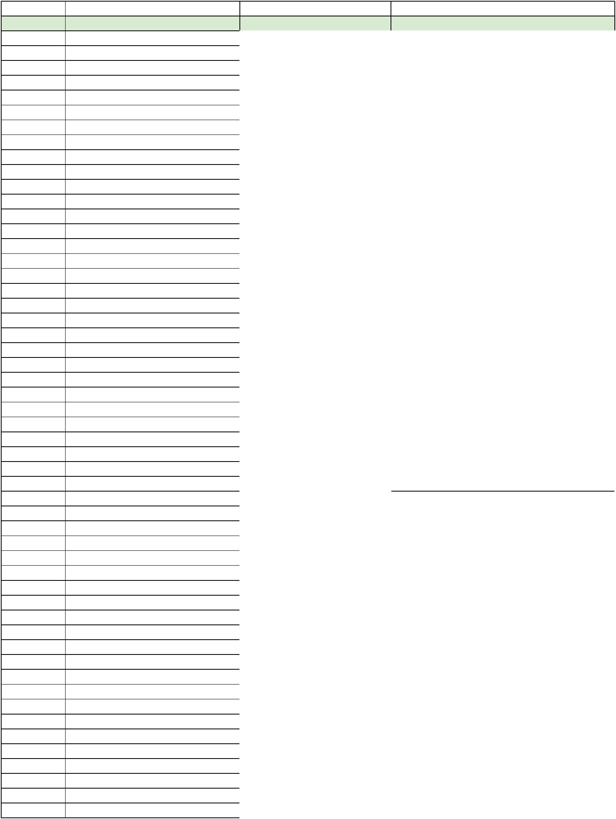**Approx. Time** **When** **Artist** **Song**

|  |  |  |
| --- | --- | --- |
|  | Harry Belafonte | A Legendary Performer |
|  | Harry Belafonte | 15 Greatest Hits |
|  | Harry Belafonte & Mouskouri | An Evening With Belafonte/Mouskouri |
|  | Harry James | Jazz Session |
|  | Heart | Dog & Butterfly |
|  | Heart | Heart |
|  | Henry Mancini | The Music from Peter Gunn |
|  | Henry Mancini | More Music from Peter Gunn |
|  | Herb Alpert & the Tijuana Brass | Greatest Hits |
|  | Herb Alpert & the Tijuana Brass | Whipped Cream & Other Delights |
|  | Herbert Grönemeyer | 4630 Bochum |
|  | Herbert Grönemeyer | Gemischte Gefühle |
|  | Huey Lewis & the News | Sports |
|  | Irish Rovers | All Hung Up |
|  | Irish Rovers | Greatest Hits |
|  | Irish Rovers | On The Shores of Americay |
|  | Isaac Stern | Violin Concertos by Beethoven & Brahms |
|  | Jacques Brel | Jacques Brel |
|  | James Bay | Chaos And The Calm |
|  | James Bond | The Man with the Golden Gun |
|  | James Last | Dancing a gogo |
|  | Jamie XX | In Color |
|  | Jerry Vale | Jerry Vale's Greatest Hits |
|  | Jessica Dragonette | With Love |
|  | Jim Croce | His Greatest Hits |
|  | Joe Valle | Cante y Baile Con |
|  | John Denver | Greatest Hits |
|  | John Denver | Greatest Hits, Volume II |
|  | John Denver | Rocky Mountain High |
|  | John McCormack | Sings Irish Songs |
|  | Johnny Cash/Tammy Wynette | Johnny Cash/Tammy Wynette The Kind/Queen |
|  | Johnny Cash | Born to Sing |
|  | Johnny Mathis | Johnny Mathis Greatest Hits |
|  | Joni James | Little Girl Blue |
|  | Juan Serrano | Popular Music of Spain and Old World |
|  | Juan Serrano | Ole, La Mano! |
|  | Judy Collins | A Maid of Constant Sorrow |
|  | Judy Garland | Judy |
|  | Judy Garland | The Best of Judy Garland |
|  | Katy Perry | Teenage Dream |
|  | Kenny Rogers | Greatest Hits |
|  | Kenny Rogers | Kenny Rogers & The First Edition Greatest Hits |
|  | Kenny Rogers & the Gamblers | Kenny Rogers |
|  | Kenny Rogers & the Gamblers | Ten Years of Gold |
|  | Krafwerk | Autobahn |
|  | La Rondalla Tapatia | 22 Guitars 22 Voices |
|  | Led Zeppelin | Led Zeppelin |
|  | Les Miserables | The Musical |
|  | Linda Ronstadt | Greatest Hits |
|  | Linda Ronstadt | Heart Like A Wheel |
|  | Line Renaud | CBS |
|  | Lionel Ritchie | Can't Slow Down |
|  | Little Dublin Singers | Christmas in Ireland |

**Approx. Time** **When** **Artist** **Song**

|  |  |  |
| --- | --- | --- |
|  | London Grammar | If You Wait |
|  | Lou Rawls | Lou Rawls Live |
|  | Louis Armstrong | The Best of Louie Armstrong |
|  | Luciano Pavarotti | King of the High C's |
|  | Luciano Pavarotti | Favorite Neapolitan Songs |
|  | Luciano Pavarotti | Pavarotti Premiees Rare Verdi Arias |
|  | Luciano Pavarotti | Pavarotti Anniversary |
|  | Luciano Pavarotti | Pavarotti Passione |
|  | Luciano Pavarotti | Verismo Arias |
|  | Luciano Pavarotti | Gala Concert at the Royal Albert Hall |
|  | Madeon | Adventure |
|  | Madonna | True Blue |
|  | Madonna | Madonna |
|  | Mahalia Jackson | Welcome to Europe |
|  | Mahalia Jackson | Stille Nacht |
|  | Mahalia Jackson | Grösste Erfolge |
|  | Mahalia Jackson | Starportrait |
|  | Mama's & The Papas | If You Can Believe Your Eyes and Ears |
|  | Mama's & The Papas | Mama's & The Papas |
|  | Maria Callas | Arias by Beethoven, Mozart and Weber |
|  | Maria Callas | Puccini Heroines |
|  | Maria Callas | The Art of Maria Callas Vol. 3 Lyric & Coloratura Arias |
|  | Maria Callas | Callas Portrays Verdi Heroines |
|  | Maria Livia Sao Marcos | The Classical Brazilian Guitar |
|  | Mario Escudero | Mario Escudero |
|  | Mario Lanza | Sings Caruso Favorites |
|  | Marlene | Wiedersehen mit Marlene |
|  | Martin Denny | Quiet Village |
|  | Mary Martin & Ezio Pinza | South Pacific |
|  | Mary Poppins | Story And Songs From Walt Disney's |
|  | Mathias Kaden | Energetic |
|  | Maurice André | King of the Trumpet |
|  | Men at Work | Business As Usual |
|  | Michael Jackson | Thriller |
|  | Michael Kiwanuka | Love and Hate |
|  | Mirelle | Merveilleuse Mirelle |
|  | Mirelle | Merci Mireille |
|  | Missa Luba | Les Troubadours Du Roi Baudouin |
|  | Mitch Miller & the Gang | Christmas Sing Along |
|  | Mitch Miller & the Gang | Holiday Sing Along |
|  | MNDR | Feed Me Diamonds |
|  | Modern English | After the Snow |
|  | Mozart | Violin |
|  | Mozart & Haydn | Mozart No 40 G Minor, Haydn No 104 |
|  | Mozart, Wolfgang Amadeus | The Mozart Album - Various |
|  | Mozart, Wolfgang Amadeus | Symphonie Nr. 38 & 34 |
|  | Music for 2 Guitars | Dances and songs from Spain & Latin America |
|  | Music Treasures Of The World | Symphonie Classics |
|  | Mutemath | Vitals |
|  | My Fair Lady | Rex Harrison & Julie Andrews |
|  | Naked Music Trax | Nightsource the rise above ep |
|  | Nana Mouskouri | Vielles Chansons de France |
|  | Nana Mouskouri | Comme un Soleil |

**Approx. Time** **When** **Artist** **Song**

|  |  |  |
| --- | --- | --- |
|  | Nana Mouskouri | Le Tournesol |
|  | Nancy Wilson | Kaleidoscope |
|  | Nancy Wilson | Can't Take My Eyes Off of You |
|  | NAS | Illmatic XX |
|  | Nat King Cole | Ramblin' Rose |
|  | Neil Diamond | The Jazz Singer |
|  | Neil Diamond | Stones |
|  | Neil Diamond | Love Songs |
|  | Neil Diamond | Tap Root Manuscripts |
|  | Neil Diamond | Beautiful Noise |
|  | Neil Diamond | Gold - Live At The Troubadour |
|  | Neil Diamond | Love At The Greek |
|  | Neil Diamond | Jonathan Livingston Seagull |
|  | Neil Diamond | Moods |
|  | Neil Diamond | You Don't Bring Me Flowers |
|  | Neil Diamond | 12 Greatest Hits Vol. II |
|  | Neil Young | Everybody Knows this is Nowhere |
|  | Odesza | In Return |
|  | Oktoberfest with Rudi's Sauerkraut S | Compilation |
|  | Old Erin | New Music from Old Erin |
|  | Pachelbel & Fasch | Canon in D Major & Others |
|  | Pantha Du Prince | The Triad |
|  | Pat Benatar | Precious Time |
|  | Pat Boone | Pat Boone |
|  | Patsy Cline | Showcase |
|  | Paul Simon | Graceland |
|  | Paul Weston | Music for Romancing |
|  | Paul Weston & His Orchestra | Hollywood |
|  | Peg & Bobby Clancy | Traditional Songs of Ireland |
|  | Peggy Lee | I'm a Woman |
|  | Penguin Rock | Lazyboy |
|  | Peter And The Wolf | Disney Presents |
|  | Peter Gabriel | So |
|  | Peter Maffay | Frei Sein |
|  | Phantogram | Nightlife |
|  | Phil Collins | Face Value |
|  | Polly Bergen | The Party's Over |
|  | Prince | Purple Rain |
|  | Puccini | La Bohéme |
|  | Queen | Greatest Hits |
|  | Randy Travis | Storms of Life |
|  | Randy Travis | Always & Forever |
|  | Ray Charles | A Man And His Soul |
|  | Ray Coniff & His Orchestra | S' Marvelous |
|  | Requiem | Requiem |
|  | Rey De La Torre Guitar | Spanish Music for the Classic Guitar |
|  | Robert Schumann | Symphonie Nr. 3 Rheinische |
|  | Rob Base & D.J. E-Z Rock | It Takes Two |
|  | Roberto Yanes | Love Letters |
|  | Robin Schulz | Extended Prayer |
|  | Robin Williams | reality...what a concept |
|  | Rod Stewart | Atlantic Crossing |
|  | Rod Stewart | Out Of Order |

**Approx. Time** **When** **Artist** **Song**

|  |  |  |
| --- | --- | --- |
|  | Rosanne Cash | Seven Year Ache |
|  | Roxy Music | Avalon |
|  | Rudolph Valentino | Tangos |
|  | Russ Morgan | All Time Hits |
|  | Sade | Diamond Life |
|  | Sam Cooke | Portrait of a Legend |
|  | Sam Smith | In the Lonely Hour |
|  | Sandler & Young | On The Move |
|  | Schubert, Franz | The Unfinished Symphony |
|  | Seoul | I Become A Shade |
|  | Sergio Franchi | Romantic Italian Songs |
|  | Sergio Mendes | Favorite Things |
|  | Sergio Mendes & Brasil | Crystal Illusions '66 |
|  | Sergio Mendes & Brasil | Greatest Hits '66 |
|  | Sergio Mendes & Brasil | País Tropical '77 |
|  | Sergio Mendes & Brasil | Love Music '77 |
|  | Sergio Mendes & Brasil | Equinox '66 |
|  | Sergio Mendez & Brasil '66 | Look Around |
|  | Sesame Street 2 | Book And Record Album |
|  | Shirley Bassey | And I Love You So |
|  | Shirley Bassey | Something Else |
|  | Shirley Bassey | Love, Life & Feelings |
|  | Sia | Spotify Sessions |
|  | Simon & Garfunkel | The Concert in Central Park |
|  | Simon & Garfunkel | Bridge Over Troubled Water |
|  | Sleeping Beauty | Told And Sung By Mary Martin |
|  | Songs of the Civil War | Songs of the Civil War |
|  | Sound Of Music | The Sound Of Music |
|  | St Lucia | Matter |
|  | Star Wars | Star Wars |
|  | Straight Outta Compton | Music From The Motion Picture |
|  | Stunde Der Stars | Compilation |
|  | STYX | The Grand Illusion |
|  | Tammy Wynette | Tammy's Greatest Hits |
|  | Tammy Wynette | Bedtime Story |
|  | Taylor Swift | 1989 |
|  | Tchaikovsky | Concerto No. 1 |
|  | Tchaikovsky | Nutcracker Suites Nos. 1 and 2 |
|  | Tchaikovsky | The Nutcracker Ballet - London Symphony |
|  | Testiculo y Uno | Hi-Hat Club Vol. 1s |
|  | The Chieftans | Ballad of the Irish Horse |
|  | The Cure | Disintegration |
|  | The Harry Simeone Chorale | Sing We Now of Christmas |
|  | The Jezabels | The Brink |
|  | The Jezabels | Prisoner |
|  | The Jezabels | Synthia |
|  | The Jezabels | The Man Is Dead |
|  | The Jezabels | She's So Hard |
|  | The Impressions | Greatest Hits |
|  | The Irish Rovers | The Unicorn |
|  | The Manhattan Transfer | doo-wopp |
|  | The National | Trouble Will Find Me |
|  | The Police | Synchonicity |

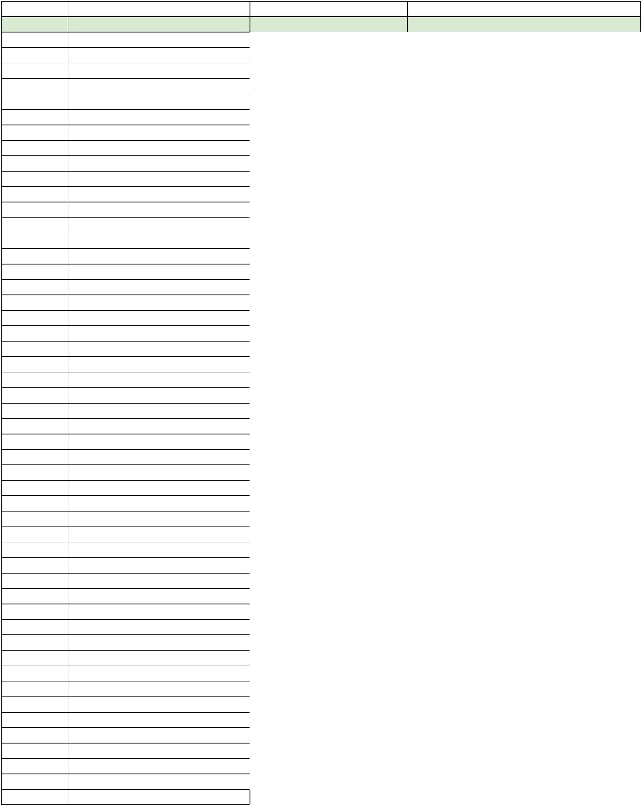**Approx. Time** **When** **Artist** **Song**

|  |  |  |
| --- | --- | --- |
|  | The Temptations | The Sky's the Limit |
|  | The Temptations | The 25th Anniversary |
|  | The XX | XX |
|  | Tommy Dorsey & Frank Sinatra | The Radio Years 1940-42 |
|  | Tommy Edwards | The Very Best of Tommy Edwards |
|  | Tommy Garrett | 50 Guitars Go Italiano |
|  | Tony Bennett | Tony Makes it Happen! |
|  | Tony Bennett | I Left My Heart in San Francisco |
|  | Tony Bennett | At Carnegie Hall June 1962 |
|  | Tony Bennett | Greatest Hits Volume III |
|  | Tony Mottola | Roman Guitar |
|  | Top Gun | Compilation |
|  | Tycho | Awake |
|  | Tycho | Past Is Prologue |
|  | Tycho | Dive |
|  | Tycho | Awake Remixes |
|  | U-Roy | Dread In A Babylon |
|  | U2 | Achtung Baby |
|  | U2 | Boy |
|  | U2 | Joshua Tree |
|  | U2 | C'mon Everybody |
|  | U2 | BBC Transcription Services |
|  | U2 | The New Rehearsals & Full Versions Gold |
|  | U2 | The New Rehearsals & Full Versions Gold |
|  | U2 | Pop |
|  | U2 | All I Want Is You |
|  | U2 | Where The Streets Have No Name |
|  | U2 | Mysterious Ways |
|  | U2 | Rattle And Hum |
|  | U2 | Desire |
|  | U2 | Pride (In The Name Of Love) |
|  | U2 | Discothéque |
|  | U2 | Joshua Three |
|  | U2 | October |
|  | U2 | War |
|  | U2 | Under a Blood Red Sky |
|  | U2 | Daughters and Songs Demos 1978-1979 |
|  | Udo Jürgens | Udo Live |
|  | Van Halen | Van Halen |
|  | Vaudeville | Songs of the Great Ladies of the Musical Stage |
|  | War of the Worlds | Orson Welles Fake Radio Broadcast |
|  | Warrant | Dirty Rotten Filthy Stinking Rich |
|  | Waylon | Greatest Hits |
|  | West Side Story | The Original Soundtrack Recording |
|  | Whitesnake | Whitesnake |
|  | Whitesnake | EP Album |
|  | Whitney Houston | Whitney Houston |
|  | Wings | At The Speed Of Sound |
|  | Worlds Great Music | Tchaikovsky & Schubert |
|  | Yehudi Menuhin & Ravi Shankar | West Meets East |